FoodTalk4You Newsletter #2
Happy February to all! The month of love! Chocolate! And....Excellence?
When you experience love in any form, isn't there always an element, a substantial element, of excellence? Whether it is a Valentine card scrawled out by our children's chubby hands, a community gospel choir singing their hearts out, or the results of a cleverly crafted lesson plan...when there's love, there is a desire to put our best efforts to the task...to be excellent.
The gentleman on the cover of the newest issue of the Excellence e-zine is none other than the man I speak of in my own book, Toolkit for Wellness. Michal Stawicki's writings and his approach to authorship, which connects author to reader in a personal fashion, have greatly influenced me along the way.
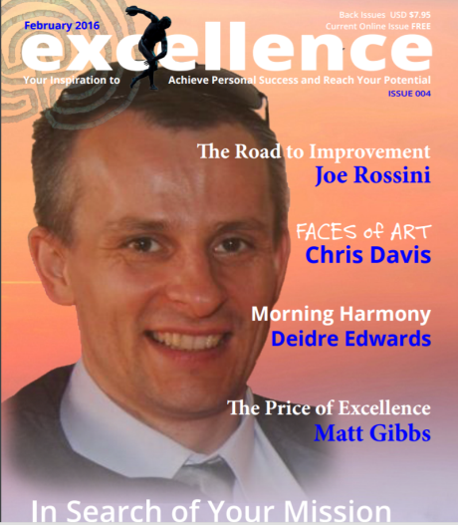
It is his connection to Anthony Smits, one of the editors of Excellence, which lead me to be asked to contribute to this month's issue in my column called, "Harmony of Purpose." Excellence is a FREE online magazine focused on shining a light on "your inspiration to achieve personal success and reach your potential."
Everyone receiving this newsletter appreciates and strives for excellence, and I would like to invite you to subscribe to this FREE creative resource for appreciating how to find and see excellence in this world and how to ramp-up your own by clicking HERE.
Each issue of Excellence explores its topic on many levels and from many angles. Cover stories reveal individuals who have applied the principles of excellence in habits to what they love and have seen tremendous success. My story this month shares a formula for creating that much needed element of harmony in our lives each morning!
Check it out!
In health, harmony, and excellence-
Deidre

